Item to Item recommendation:

For any item i,we find other similar items.Then we estimate the rating for item i,based on the rating for similar items.

We will first calculate the k most similar items to a given item.This is done by calculating the Cosine similarity between the items based on all the users that co-rated both restaurants.Then the rating for the i th item by a user A is predicted by =>multiplying the similarity between item i and item j(means for every item in k) and the rating given by user A to item j and then dividing it by summation of the similarity between the item i and item j(for every item in k).

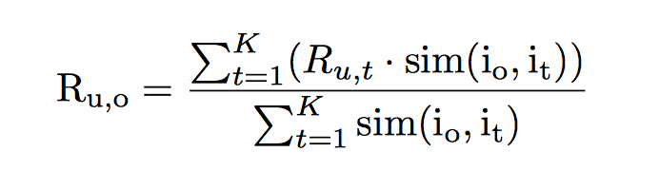

Here k=2

|  |  |  |  |  |  |
| --- | --- | --- | --- | --- | --- |
|  | User 1 | User 2 | User3 | User 4 | Sim(1,m) |
| Item 1 | 1 | ? | 3 | 2 | 1 |
| Item 2 |  | 3 | 4 | 1 | A1 |
| Item 3 | 3 | 5 | 3 | 2 | A2 |

So the rating for item 1 by user 2 will be=

( A1*3+A2*5)/(A1+A2)